**DLD Lab 06 – In-Lab Tasks**

**Task 1(a)**

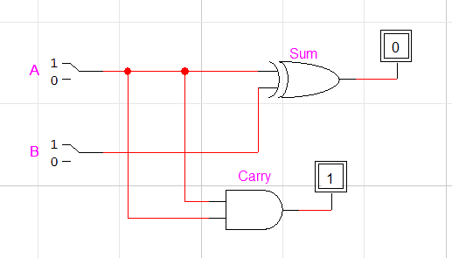

|  |  |  |  |
| --- | --- | --- | --- |
| **A** | **B** | **Sum** | **Carry** |
| 0 | 0 | 0 | 0 |
| 0 | 1 | 1 | 0 |
| 1 | 0 | 1 | 0 |
| 1 | 1 | 0 | 1 |

**Task 1(b)**

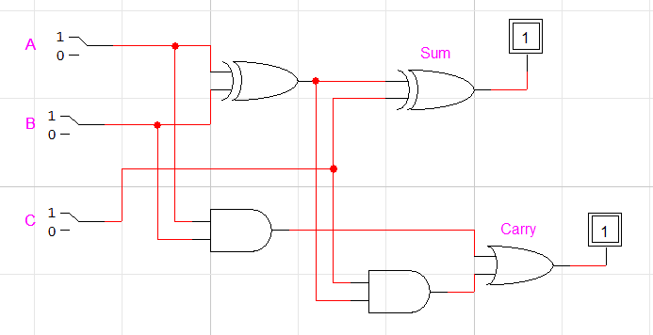

|  |  |  |  |  |
| --- | --- | --- | --- | --- |
| **INPUT** | | | **OUTPUT** | |
| **A** | **B** | **Cin** | **S** | **Cout** |
| 0 | 0 | 0 | 0 | 0 |
| 0 | 0 | 1 | 1 | 0 |
| 0 | 1 | 0 | 1 | 0 |
| 0 | 1 | 1 | 0 | 1 |
| 1 | 0 | 0 | 1 | 0 |
| 1 | 0 | 1 | 0 | 1 |
| 1 | 1 | 0 | 0 | 1 |
| 1 | 1 | 1 | 1 | 1 |

**Task 1(c)**

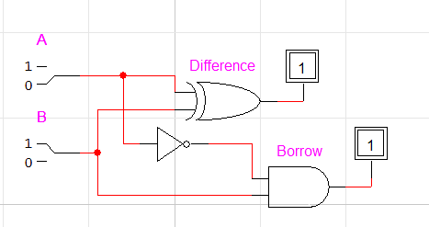

|  |  |  |  |
| --- | --- | --- | --- |
| **A** | **B** | **Difference** | **Borrow** |
| 0 | 0 | 0 | 0 |
| 0 | 1 | 1 | 1 |
| 1 | 0 | 1 | 0 |
| 1 | 1 | 0 | 0 |

**Task 1(d)**

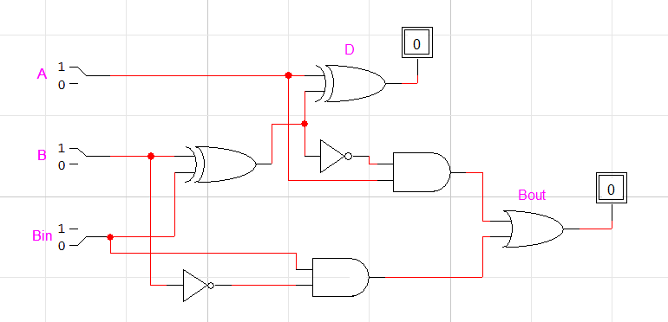

|  |  |  |  |  |
| --- | --- | --- | --- | --- |
| **INPUT** | | | **OUTPUT** | |
| A | B | Bin | D | Bout |
| 0 | 0 | 0 | 0 | 0 |
| 0 | 0 | 1 | 1 | 1 |
| 0 | 1 | 0 | 1 | 1 |
| 0 | 1 | 1 | 0 | 1 |
| 1 | 0 | 0 | 1 | 0 |
| 1 | 0 | 1 | 0 | 0 |
| 1 | 1 | 0 | 0 | 0 |
| 1 | 1 | 1 | 1 | 1 |